GRADE: V MONTHLY TEST (JULY) 2019 - 20 MARKS: 30
DATE: 01.08 .2019 SCIENCE TIME: 1½Hrs

I. Choose the correct answer: (5X1=5)

1. Which of these is an igneous rock?
a) Limestone b) granite c) coal
2. Which of these rocks can float on water?
a) Limestone b) granite c) pumice
3. Which of these minerals is commonly present in sandstone?
a) Quartz b) mica c) feldspar
4. Dentists use powdered ___________ for polishing teeth.
a) Shale b) pumice c) marble
5. Coal and petroleum are called _______ fuels.
a) Natural b) synthetic c) fossil

II. What are the following called? (3x1=3)

- The mineral present in sandstone.
- A metamorphic rock formed from shale.
- The rock that can float on water.

III. Complete the series: (3x1=3)

- Iron : haematite :: aluminium : __________
- Gold : metal :: diamond : __________
- Limestone : marble :: granite : __________

IV. Diagram based questions: (1x4=4)
- Which characteristics are found in sedimentary rocks?
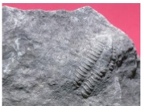

- Look at the monument carefully. Name the types of rocks.
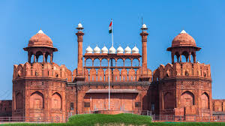
- Identify the gemstones and write the name and colour of it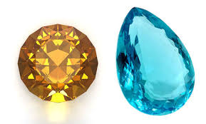 only 3 questions but marks is 4

V. Very Short answer type questions: (3x2=6)

1. Name the important minerals that are found in igneous rocks.

2. What would happen to life on the Earth when all the fossil fuel deposits get exhausted?

3. What are gemstones?

VI. Short answer type questions: (3x3=9)
- What are metamorphic rocks? How are they formed?
- Why should coal and petroleum be used carefully? How can we conserve these fuels?
- How are sedimentary rocks formed? Name the different types of sedimentary rocks. Describe any one.

